Practical 3
Create a Health Tracker API Using Express.js

Aim: To create a Health Tracker API using Express.js for managing exercise details and integrating it with a Flask Todo application.

Step 1: Check Node.js Installation
node -v
npm -v
Expected Output:
v22.18.0
10.9.3

Step 2: Initialize Node Project
npm init -y
Output:
Wrote to package.json

Step 3: Install Required Packages
npm install express axios
Output:
added XX packages
found 0 vulnerabilities

Step 4: Create health.js File
Create a file named:
health.js

Code:
const express = require("express");
const axios = require("axios");

const app = express();
const port = 3000;

// Parse JSON request bodies
app.use(express.json());

// Store health data
let healthdatas = [];

// GET all health records
app.get("/healthtracker", (req, res) => {
res.send(healthdatas);
});

// POST a new health record
app.post("/healthtracker", (req, res) => {
const healthdata = {
id: healthdatas.length + 1,
title: req.body.title,
duration: req.body.duration,
};

// Send data to Flask server
axios.post("http://127.0.0.1:5000/todos", {
task: req.body.title,
status: "completed",
})
.then((response) => {
console.log("Response from Python server:", response.data);
})
.catch((error) => {
console.error("Error posting to Python server:", error.message);
});

// Store locally
healthdatas.push(healthdata);

// Send response
res.status(201).json(healthdata);
});

// Start server
app.listen(port, () => {
console.log(`Example app listening on port ${port}`);
});

Step 5: Run the Application
node health.js
Output:
Server running at http://localhost:3000

Testing Using Postman

POST Request
Method: POST
URL
http://localhost:3000/healthcare
Body → raw → JSON
{
"title": "Morning Walk",
"duration": "30 Minutes"
}
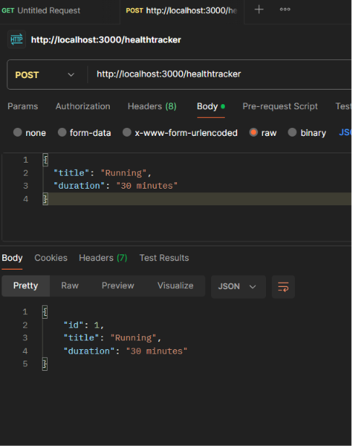
Click Send.
Expected Output:

GET Request
Method: GET
URL
http://localhost:3000/healthtracker
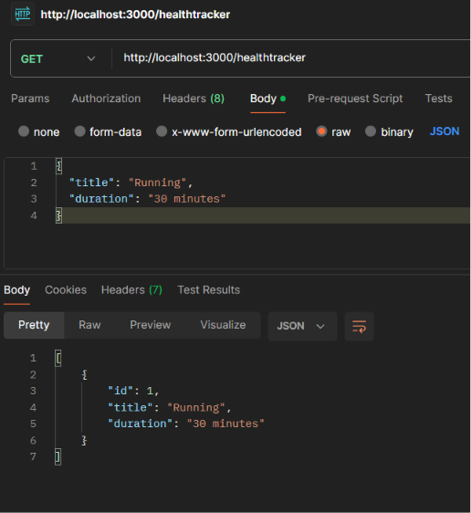
Expected Output:

